CareerAbility
Workshop Catalog

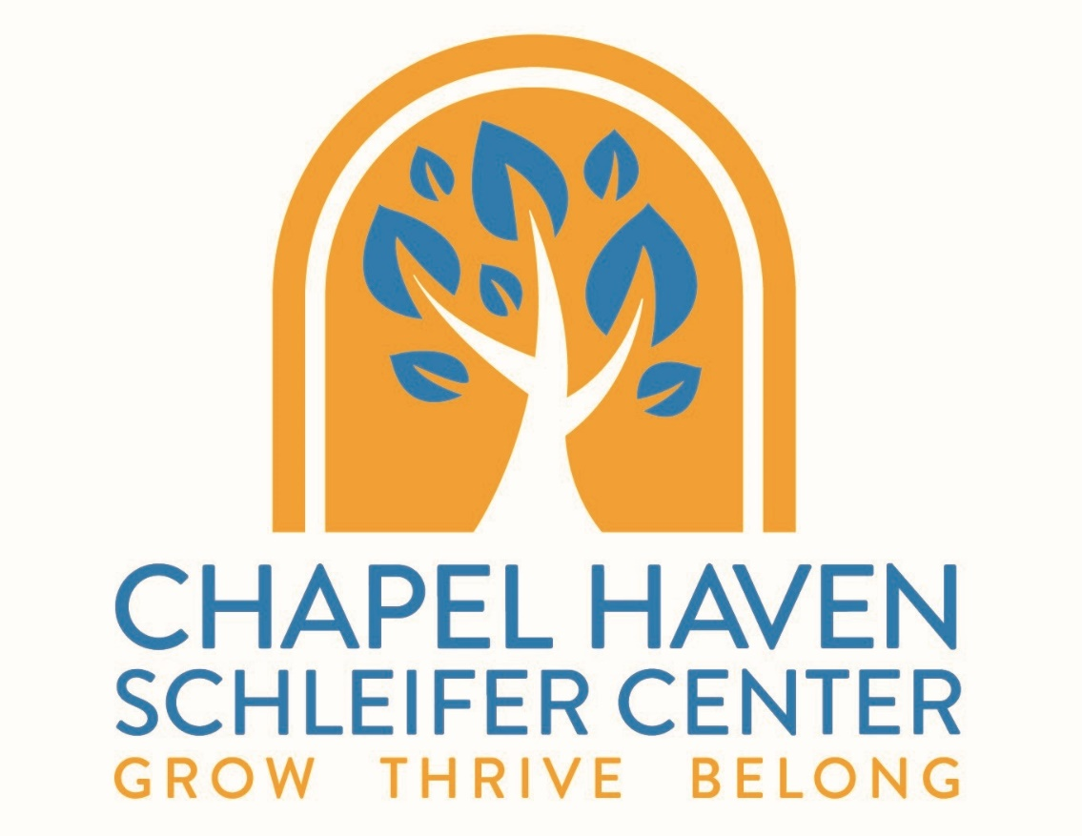

Winter
January 25, 2021 – February 26, 2021
Registration Deadline: January 6, 2021

CareerAbility Catalog
CareerAbility was founded to meet a vital element of Chapel Haven’s mission: meaningful employment for Chapel Haven’s students, as well as those in the community. CareerAbility’s model incorporates a unique combination of vocational tools and best practices: Career Exploration, Work-Based Learning, Job Skill Development, and Employment Services.

Offerings
- Classes for winter 2021 are offered only to adults affiliated with Chapel Haven.
- Classes offered virtually are marked with a computer symbol ().
- Classes offered only to current CareerAbility clients are marked with a star symbol .
- Students currently in residence may have an opportunity to attend in-person classes while adhering to hand washing and social distancing rules. In-person classes are designated with a hand symbol (). Students must wash their hands at the beginning of class and again when they return to their apartments. In person classes will be limited to 5 students or less. Students will practice social distancing in classroom spaces.

Registering
To enroll in CareerAbility workshops, individuals must meet the following criteria:
- 18 years of age or older (sorry, no exceptions).
- Able to participate effectively in a group classroom environment, including the use of technology, without individual support.
- Does not require direct supervision or pose a danger to self or others.
- Has a personal email address.

Please complete the registration sheet and drop it off into the CareerAbility mailbox in the Welcome Center or email Alix Hunter at ahunter@chapelhaven.org to sign up for a workshop or to request additional information. ​

- Deadline to sign up is 1/6/21
- Requests are processed on a first-come, first-serve basis.
- Classes may be postponed if the minimum enrollment is not met.

OPEN TO ALL STUDENTS/CLIENTS

Workplace Wednesday - Professional Development Webinars
Participants: Open to All (10 person Max) *Employment Services clients prioritized
Wednesdays: 1:00 pm – 3:00 pm (January 27, 2021 – February 23, 2021).
Location: In-person to residential students (5 Max), virtual via Zoom to Community Members (until campus re-opens)
Facilitators: Career Transition Specialists: Audree Symonds & Theda Williams
Cost: $120, or included for those in Group Supported Employment or Employment Services

Description: In these profesisonal development webinars, content will focus on your Professional and Social Capabilities. Learn more about the skills for success in employment, and how best to equip ourselves for this new world work. These weekly workshops take a deeper dive into the crucial ‘soft skills’ or ‘21st century skills’ including but not limited to, the following topics:
- Adjusting to the Workplace – First days on the work site; How a Job Coach works with you on the work site
- Working Relationships – Building relationships with co-workers; Diversity; Teamwork
- Job Retention – Asking for help, initiation, staying engaged & being productive, taking direction, strategies for job retention

Social Media: Using Social Media Safely & Professionally
Participants: Open to All (10 person Max)
Wednesdays: 9:00 am – 10:00 am (January 25, 2021 – February 22, 2021)
Location: In-Person to residential students (5 Max), virtual on Zoom to Community Members (until campus re-opens)
Facilitator: Work-Based Learning Specialist: Adam Ursone
Cost: $90, No cost to residential students

Think before you post! This workshop aims to provide students with action steps on how to uphold professional digital citizenship, such as: handling negative social media posts, how to avoid or resolve conflicts online, and the proper etiquette of the various platforms of social media: LinkedIn, Facebook, Instagram, etc.

It is important that students understand that social media is used to monitor and inform decisions, such as hiring decisions, employment, being suspended from programs/school, and/or denied admission to college. Students will review their digital footprint and build a professional LinkedIn Profile.

OPEN TO RESIDENTIAL STUDENTS ONLY

What’s Cooking with Maurice and Rich
Participants: Residential Students Only, (4 Max)
Thursdays: 2:00 pm – 4:00 pm (January 26, 2021 – February 23, 2021)
Location: Café
Facilitator: Maurice Morrison and Rich LaManna
Cost: $220 – Fee applies to residential students as it includes the cost of groceries/supplies for class.

Description: Would you like to learn how to plan and cook your favorite meals with trained chefs in a professional kitchen? Then this class is for you! In addition to being fun, preparing meals for yourself is a valuable skill that will increase your independence. Knowing what foods to buy, how to follow a recipe, and food safety are just a few examples of topics that will be covered in this class. Best of all, you will be able to take what you learn back to your own kitchen. After registering, the facilitators will reach out to ask you for 2-3 meals that you would like to learn to cook.

OPEN TO CAREERABILITY CLIENTS ONLY

Make Your Own Visual Résumé
Participants: Open only to Employment Services Clients, Phase Two prioritized (5 person max)
Tuesdays: 1:00 pm – 3:00 pm (January 26, 2021 – February 23, 2021)
Location: In-Person to residential students, virtual on Zoom to Community Members (until campus re-opens)
Facilitator: Alix Hunter, Program Administrative Assistant
Cost: $120

Learn how to integrate your career awareness and skills into a Visual or Infographic Résumé. This career-centered workshop will help students create a visual résumé for the first time. Students can create an eye-catching resume that contains a colorful snapshot of their personality and experience. Step by step, you will build a document that maps your career and accomplishments in a timeline or infographic. This is a great way to highlight specific aspects of your personality and skills for a potential employer. For the last class, you can present your résumé to members of the CareerAbility Team!

Career Development Group
Participants: Open only to Individuals in Employment Services
Tuesdays: Tuesdays: 10:00 am – 11:00 am (January 26, 2021 – February 23, 2021)
Location: Virtual via Zoom
Facilitator: Career Development Advisor: Sarah Elsdon
Cost: Included as part of Employment Services

Description: Meet weekly with CareerAbility’s Career Development Advisor to discuss progress on your career plan, talk through questions, and develop strategies as we work towards your employment goals.

Work-Based Learning Group
Participants: Open only to Work-Based Learning Students
Tuesdays: Tuesdays: 11:00 am – 12:00 pm (January 26, 2021 – February 23, 2021)
Location: Virtual via Zoom
Facilitator: Bill Angier, Work-Based Learning & Training Manager & Joe Granito, Work-Based Learning Specialist
Cost: Included as part of a Work-Based Learning Customized Individual Experience

Description: Meet weekly with CareerAbility’s Work-Based Learning staff to discuss progress on your work-based learning experience, talk through questions, and develop strategies as we work towards your employment goals.

Job Club
Participants: Open only to individuals in Phase 2 of Employment Services.
Mondays: 3:00 pm – 4:00 pm (February 1 – February 22, 2021)
Location: Virtual via Zoom
Facilitator(s): Business & Community Relations Specialist
Cost: Included as part of Employment Services

Description: Looking for work and navigating career challenges are made easier when you are not alone. CareerAbility’s Job Club is rooted in the belief that every individual has something valuable to contribute and that everyone benefits from the advice and encouragement from a diverse group dynamic. To support your job search, we will provide the basic tools to get you started and keep you motivated along the way. This includes discussion topics to facilitate a healthy give and take among attendees.

Members will discuss and swap job leads, offer feedback, conduct mock interviews, tackle challenges, and encourage one another's weekly success. Participants should leave this workshop with an understanding of how to find and apply for a variety of job openings and with suggestions for their current resume. Members are responsible for actively searching for/applying for jobs, crafting tailored application materials, and preparing for interviews. Each week, attendees will update the group on his/her self-directed job search progress and end each meeting with a commitment to address specific tasks during the week ahead. There is no shortage of content to discuss.
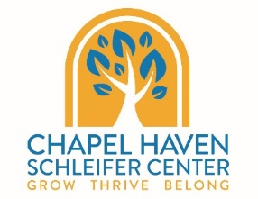
CareerAbility Workshop Registration
Name: Click here to enter text. Date of Birth: Click here to enter text.
Address: Click here to enter text.
Cell Phone Number: Click here to enter text. Email Address: Click here to enter text.
Preferred mode of communication: ☐Call ☐Text ☐ Email
I am currently affiliated with Chapel Haven Schleifer Center: ☐Yes ☐No
Main CHSC Program: Choose an item. Support Staff Name: Click here to enter text.
Parent Name: Click here to enter text.Parent Phone Number: Click here to enter text.
Parent Address: Click here to enter text.
Access to: ☐ Laptop ☐ iPad ☐Chromebook ☐Computer ☐ Smartphone ☐No access to a device
Familiar with Zoom: ☐ Yes ☐ No
Please check off all classes for which you would like to register:
Class | Day/Time | Cost | Register X
Career Development Group | Tuesdays 10:00 am – 11:00 am  Open to Employment Services Clients Only | Included in Employment Services | ☐
Workplace Wednesday-Professional Development | Wednesdays 1:00 pm – 3:00 pm  Open to All | $120.00 or included as part of GSE or Employment Services | ☐
Job Club | Mondays 3:00 pm -4:00 pm  (Begins in February)  Open to Phase Two Employment Services Clients Only | Included in Phase Two of Employment Services | ☐
Work-Based Learning Development Group | Tuesdays 11:00 am-12:00 pm  Open to Work-Based Learning Students Only | Included with WBL Customized Individual Experience | ☐
Make Your Own Visual Resume | Tuesdays 1:00 pm -3:00 pm  Open to Employment Services Clients Only | $120.00 | ☐
Using Social Media Safely and Professionally | Wednesdays 9:00am - 10:00am  Open to All | $90.00, no fee for residential students | ☐
What’s Cooking with Maurice and Rich | Thursdays 2:00 pm - 3:00 pm  Residential Students Only | $220.00 | ☐
You must sign up by January 8th, 2021 if you wish to take part in the full series. Please email this page to Alix Hunter at ahunter@chapelhaven.org to register or place into the CareerAbility mailbox in the Welcome Center.

