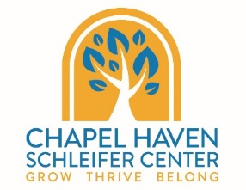
CareerAbility Workshop Registration
Name: Click here to enter text. Date of Birth: Click here to enter text.
Address: Click here to enter text.
Cell Phone Number: Click here to enter text. Email Address: Click here to enter text.
Preferred mode of communication: ☐Call ☐Text ☐ Email
I am currently affiliated with Chapel Haven Schleifer Center: ☐Yes ☐No
Main CHSC Program: Choose an item. Support Staff Name: Click here to enter text.
Parent Name: Click here to enter text.Parent Phone Number: Click here to enter text.
Parent Address: Click here to enter text.
Access to: ☐ Laptop ☐ iPad ☐Chromebook ☐Computer ☐ Smartphone ☐No access to a device
Familiar with Zoom: ☐ Yes ☐ No
Please check off all classes for which you would like to register:
Class | Day/Time | Cost | Register X
Career Development Group | Tuesdays 10:00 am – 11:00 am  Open to Employment Services Clients Only | Included in Employment Services | ☐
Workplace Wednesday-Professional Development | Wednesdays 1:00 pm – 3:00 pm  Open to All | $120.00 or included as part of GSE or Employment Services | ☐
Work-Based Learning Development Group | Tuesdays 4:00-5:00 pm  Open to Work-Based Learning Students Only | Included with WBL Customized Individual Experience | ☐
Make Your Own Visual Resume | Tuesdays 1:00 pm -3:00 pm  Open to Employment Services Clients Only | Included in Employment Services | ☐
You must sign up by March 15th, 2021 if you wish to take part in the full series. Please email this page to Alix Hunter at ahunter@chapelhaven.org to register or place into the CareerAbility mailbox in the Welcome Center.

