Hello,
Below you will find the course catalog for Continuing Adult Education and the Wellness Program. Individuals should look over this catalog for courses they are interested in, and then speak with their Support Staff to request classes.
Once all class requests are received, Program Directors will approve, and confirmations will go out. Please see below for important dates, policies, and contact information.
IMPORTANT DATES
- March 4 – March 15, 2024 - Spring Registration
- March 22, 2024 – Spring Registration Confirmations Sent Out
- April 1, 2024 - Spring Term Begins
- April 1 – 19, 2024 - Add/Drop Period
- June 14, 2024 - Spring Term Ends
ADD/DROP
The first three weeks of the term are designated as the Add/Drop period, during which time a student may enroll in or drop out of a class. A student may drop out of a class during this time without being billed. Students will not receive a full refund after April 19, 2024.
QUESTIONS
Continuing Adult Ed Related Courses:
Please direct questions to cgrandy@chapelhaven.org.
Wellness Related Courses:
Please direct questions to Wellness@ChapelHaven.org
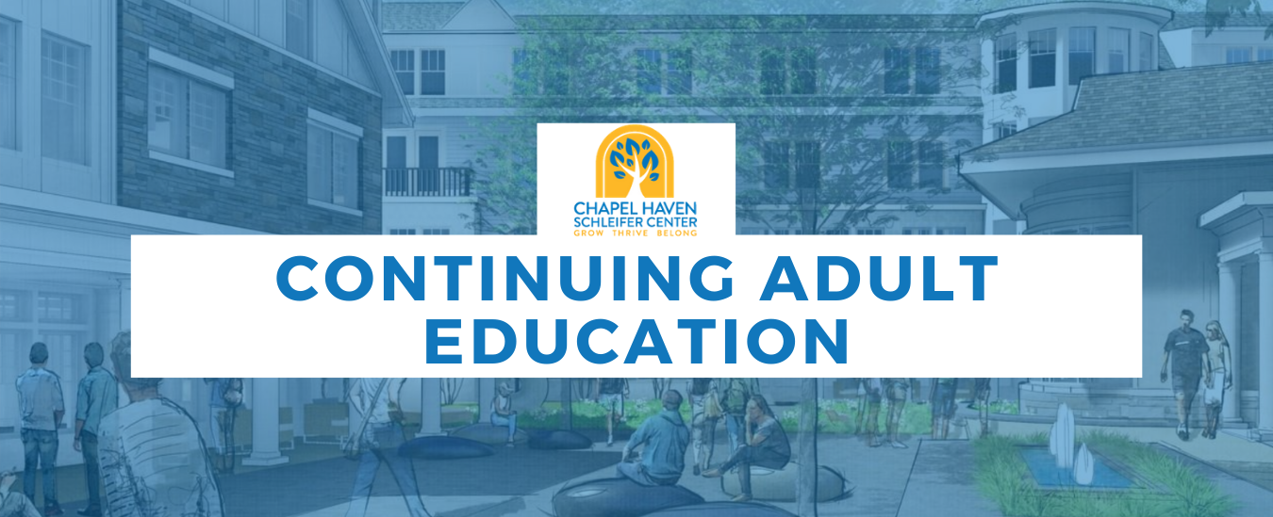
Chapel Haven Schleifer Center’s REACH program centers on a rich offering of functional academics with the main goal of preparing our students to live independently in the community. Our Functional Academic classes form the core of the REACH curriculum and are divided into 13 curriculum areas (Language Arts, Social Studies, Math, Science, Art, Career Education, Consumer Education, Physical Education, Vocational Skills, Technology, Health & Safety, Social Communication and Leisure Management). Residents must meet a certain number of distribution requirements in order to graduate from the residential program. Community members, as in any adult education program, may enroll in any of the classes that interest them except those that are designated for residents only.
As a state approved private special education facility, we employ a teaching staff of both certified and non-certified professionals who attend not only to their classes’ subject matter, but also to the personal growth and enrichment of their students as individuals. Great care is taken in designing the continually expanding course selection to meet the needs and interests of our students. In addition to directly preparing the students for independent living, the classes in our core curriculum, as well as our enrichment classes, incorporate thirteen blended subject areas (listed below).
The driving purpose and foundation of our education program is the integration of our students into the community. We recognize that this can be accomplished only if we teach explicitly and incidentally the social skills that make up the “hidden curriculum” that is essential to success in any community setting. To teach this hidden curriculum, we have designed each of our functional classes so that students learn concrete life skills such as clothing management and grocery shopping through a social communicative competence lens. Our curriculum takes the same approach to teaching problem solving skills, which are a skill set that is essential and transferable across any life skill or community interaction.
This comprehensive program is just one layer in the foundation upon which our residents build lives of successful independence.

CHAPEL HAVEN SCHLEIFER CENTER  CONTINUING ADULT EDUCATION |  |  |  | SPRING 2024
 | MONDAY | TUESDAY | WEDNESDAY | THURSDAY | FRIDAY
7-9
9-10
10-11 | BA-Local History A (S1)  DF-Small Talk D (122)  (Community only)  TM-Basic Ceramics J (OR) | KF-Citizenship A (S2)  PM-Gettin’ Jiggy with It A (CRA) | JS-Comm. Resources A (S2)  PM-Stress Mngmnt C (S1) | JS-Men’s Group D (S1)  KF-Women’s Group D (S2)  PM-Legends of Music B (OR) | MR-Hot Topic Review A (S1)  PM-Pictionary A (S2)
11-12 | KF-The Big Picture A (S1)  PM-Animal Science C (S2) | KF-Consumer Edu. B (S2)  JS-Cultural Perspect. A (S1) | JS-Cultural Perspect. B (S1)  PM-Legends of Music A (S2) | JS-US Presidents A (S1)  TM-Jewelry Making J (S2) | KF-Kindness Campaign A (S1)  PM-Gettin’ Jiggy With It B (OR)
12-1 | LUNCH | LUNCH | LUNCH | LUNCH | LUNCH
1-2 | MR-Movie Club C (S2)  TM/HM-Basic Ceramics K (OR) | JS-Anger Mngmnt. B (S1)  MR-What’s Happening C (OR)  HM-Diamond Painting C (S2) | PM-Animal Science D (S1)  TM-Art. Woodwork E (OR)  HM-Arts & Crafts B (S2) | PM-Current Events G (S2)  HM/TM-Chorus B (OR) | PM-Celeb. the Century B (S1)  MR-Hangman C (405)  TM-Jewelry Making K (S2)
2-3 | MR-Wild Things A (S1)  PM-Celebrity Facts B (S2)  TM/HM-Basic Ceramics L (OR) | MR-Celeb. the Cent. A (S1)  WG-Basketball E (BC)  HM-Diamond Painting D (S2) | WG-Backyard Games B (CY)  TM-Express. Paint. D (OR)  HM-Musical Instruments B (S2) | MR-Wild Things B (S2)  WG-Basketball F (BC)  TM-Out to Art C (S1) | MR-Walk Westville I (CY)  TM/HM-CH Idol B (OR)
AFTERNOON/EVENING SCHEDULE
3-4 | MP-WWE Club D (S2)  SP-International Theme Parks B (V) | HM-Paint by Numbers B (S2)  SP-America’s Funniest Home Videos B (V) | TM-CH Theater C (OR)  [3:00-4:30p]  MP-Walk Westville H (CY) | MP-Bingo D (S2)
4-5 | JL-Current Events F (S2)  SP-All Things Disney D (V) | SP-Virt. Travel the World C (V) |  | SP-Chat with Sue D (V)
5-6

IN-PERSON CLASS OFFERINGS

ANGER MANAGEMENT with Julian Sandoval

Anger is a signal, and one worth listening to. Your anger may be a message that you are being hurt, that your rights are being violated, that your needs are not being met, or that something is not right. Learn how to set boundaries, be more assertive, and resolve conflict without "losing your cool." Use your anger as a starting point to change patterns rather than to blame others. You don't have to get rid of your anger, but it is important to understand where it comes from and learn to take different actions on your own behalf.
Session B - Tue. 1:00-2:00pm Class Fee - $125

ANIMAL SCIENCE with Pam Murray

Learning about animals is a naturally motivating process that also teaches about citizenship, respect, and responsibility. In this class, students will develop their knowledge about the various types of animals living around them, not only in their own communities, but also in the rest of the world.
Session C – Mon. 11:00-12:00pm Class Fee - $125
Session D – Wed. 1:00-2:00pm Class Fee - $125

ARTISTIC WOODWORKING with Tina Menchetti

Practical and fun! Create a piece of artwork that’s useful and beautiful! In this class students will learn more about wood pieces and different decorating techniques such as sponging, stencils and decals. During the first class we will discuss techniques and projects.

Session E - Wed. 1:00-2:00pm Class Fee - $155
ARTS & CRAFTS with Heather McDonald

Let’s get crafty! Winter is here and that means more indoor activities are on demand. We will use crafty items as well to create various works of art. Bring your creativity and ideas to this class!
Session B - Wed. 1:00-2:00pm Class Fee - $155

BASIC CERAMICS with Tina Menchetti & Heather McDonald

Students will learn to clean, paint and glaze molded ceramics pieces. Students will also learn different decorating techniques. This is a great opportunity to create useful items for home and gifts.
Session J – Mon. 10:00-11:00am Class Fee - $155 (Tina)
Session K – Mon. 1:00-2:00pm Class Fee - $155 (Tina & Heather)
Session L – Mon. 2:00-3:00pm Class Fee - $155 (Tina & Heather)

BASKETBALL with Wilson Goodwin

Come play team basketball with your friends and classmates on Chapel Haven’s very own basketball court! Students will work on skill-building drills as well as play structured games.
Session E – Tue. 2:00-3:00pm Class Fee - $125

Session F – Thu. 2:00-3:00pm Class Fee - $125

BACKYARD GAMES with Wilson Goodwin
Students will get together each week and choose from a handful of classic backyard games –Frisbee, wiffleball, ring toss and corn hole are just some of the options. This class will offer social and leisure activities where students can spend time with friends and talk about their day while enjoying some friendly competition.
Session B – Wed. 2:00-3:00pm Class Fee - $125

BINGO with Michael Pretlove

Grab your bingo cards and have some fun playing BINGO with Michael from REACH. Bingo cards will be distributed to participants prior to the start of the class.
Session D – Thu. 3:00-4:00pm Class Fee - $125

CELEBRITY FACTS with Pam Murray
Did you know that Kobe Bryant played on one team throughout his entire 20 years in the NBA? Did you know that Lady Gaga taught herself to play the piano at only 4 years old? Who is your favorite celebrity and how much do you know about them? Join this class every week and share everything you know about your favorite celebs. If you don’t know much, that is okay! Luke will help you do some research so you can share all of the known facts for the celebrities of your choice!
Session B – Mon. 2:00-3:00pm Class Fee - $125

CELEBRATING THE CENTURY with Mylissa Rockefeller/Pam Murray
Let’s take a trip through the 21st century! This class will highlight the people, places, events, and trends of the century. Topics students will explore include Arts and Entertainment, Sports, Science and Technology, and Lifestyle of the 2000’s!

Session A – Tue. 2:00-3:00pm Class Fee - $125 (Mylissa)

Session B – Fri. 1:00-2:00pm Class Fee - $125 (Pam)

CHSC IDOL with Tina Menchetti & Heather McDonald

Do you have what it takes? Can you sing any of the top ten hits or maybe you have a favorite from the past? Can you dance like a ballerina or is hip hop more of your style? Do you play classical music or do you like to beat on a drum set? Are you the next Houdini with your magic skills? Come show your hidden talents for all to see! We are looking for talent of all types-show us what you got!

Session B – Fri. 2:00-3:00pm Class Fee - $125

CHSC THEATER with Tina Menchetti

Be part of the Chapel Haven Theater Group and experience the drama we create as a group project. We will include dialog, music, dance, comedy and improvisation. Students will be part of the choreography, set design, costumes, music, make-up and more. Come join the fun and be part of a very creative group of actors! Due to our annual talent show, we will not have a play at the end of the semester.

Session C – Wed. 3:00-4:30pm Class Fee - $275

CHORUS with Heather McDonald & Tina Menchetti

Come and be a part of the Chapel Haven Chorus! During the first few classes, we will choose the songs that we are going to perform at our concert to be held at the end of the semester. Come to rehearsal each week ready to sing and with your dancing shoes on!
Session B – Thu. 1:00-2:00pm Class Fee - $125

CITIZENSHIP with Kim Freeman

Living independently in one’s community involves more than using public transportation, doing your own banking and grocery shopping. Living independently also means becoming a responsible and productive member of the interdependent web of people that we call our community. It is about being a citizen. This class will focus primarily on the personal qualities that make a good citizen – kindness, honesty, responsibility, humility, and perseverance, among others. Students will be encouraged to apply these values and personal qualities in class, in the residence, and in the wider community.
Session A – Tue. 10:00-11:00am Class Fee - $125

COMMUNITY RESOURCES with Julian Sandoval
Students will learn how to identify and utilize the community resources available to them. Students in this class will research and develop a list of services in the community that are of value to them. Once students identify their list, they will learn how to independently access these services through class outings. Students will then utilize the skills learned to independently complete group and individual assignments.
Session A – Wed. 10:00-11:00am Class Fee - $125

CONSUMER EDUCATION with Kim Freeman
We spend money, we save money, and we earn money. We are also tempted by the “great deals” we see in colorful print ads or the side banners of our favorite websites. As consumers, we have a responsibility to ourselves to be careful consumers. A careful consumer uses a combination of problem solving skills, social skills, and basic math skills to make wise decisions when using and purchasing goods and services. This class uses real world examples and case studies to teach students how to be careful and educated consumers while shopping at clothing stores.
Session B – Tue. 11:00-12:00pm Class Fee - $125

CULTURAL PERSPECTIVES with Julian Sandoval

Each of us has our own perspective on what happens around us just like each country and culture has its own way of looking at things. In this class, students will explore the cultures and viewpoints of different people from around the world and around the country. They will also explore different foods, languages, and music.
Session A – Tue. 11:00-12:00pm Class Fee - $125
Session B – Wed. 11:00-12:00pm Class Fee - $125

CURRENT EVENTS with Dr. Jules Landswirth/Pam Murray

This class will discuss local, national and international events that appear in the newspaper and on the Internet. Students will have the opportunity to discuss and share their opinions with their peers.
Session F – Mon. 4:00-5:00pm Class Fee - $95 (Dr. Jules) No classes held on 5/13, 5/20, & 5/27
Session G – Thu. 1:00-2:00pm Class Fee - $125 (Pam)

DIAMOND PAINTING with Heather McDonald
If you want to create a painting that sparkles and is made out of tiny “diamond” beads, this class is for you! Students will learn this technique on how to make a diamond painting. Keep in mind it is meticulous and takes patience, but the final product is stunning!

Session C – Tue. 1:00-2:00pm Class Fee - $155

Session D – Tue. 2:00-3:00pm Class Fee - $155

EXPRESSIVE PAINTING with Tina Menchetti
Join us as we experiment with paint and color to express your inner thoughts and feelings. Discover the power of painting. We will study various types of painting including landscapes, portraits and abstract.
Session D – Wed. 2:00-3:00pm Class Fee - $155

GETTING JIGGY WITH IT with Pam Murray

Do you love dancing to today’s hottest songs?! Want to learn those hip new moves that all the cool kids are doing? This exciting class combines the hottest pop and hip-hop songs with exciting dance routines. Each class you’ll perfect old routines and learn new steps until you’re “gettin’ jiggy with it” like a pop star – all while getting a great workout!
Session A – Tue. 10:00-11:00am Class Fee - $125
Session B – Fri. 11:00-12:00pm Class Fee - $125

HANGMAN with Mylissa Rockefeller

Have you ever dreamed of being on Wheel of Fortune??? Well, a game of Hangman with your friends is probably the next best thing! Join Mylissa each week for this fun and challenging game and be the first to guess the word or phrase!
Session C – Fri. 1:00-2:00pm Class Fee - $125

HOT TOPIC REVIEW with Mylissa Rockefeller

Do you enjoy keeping up with the latest news? Do you want to read about exciting things that are happening in the world? Do you like having interesting conversations about new topics? This class will offer the opportunity to do all of the above! Similar to a book club, students will get together on a weekly basis to read about the latest hot topics from various publications and engage in lively and analytical discussion afterwards.

Session A – Fri. 10:00-11:00am Class Fee - $125

JEWELRY MAKING with Tina Menchetti

In this class, students will create jewelry out of beads, baubles and even elastic bands. We will make key chains, necklaces and bracelets among other things. Test your fine motor skills and try the very popular “Rainbow Loom”; bracelets made of colorful elastic bands. Make gifts or keep them for yourself. Either way, you’ll leave with great jewelry. All supplies included.
Session J – Thu. 11:00-12:00pm Class Fee - $155
Session K – Fri. 1:00-2:00pm Class Fee - $155

KINDNESS CAMPAIGN with Kim Freeman

Gandhi said, “You have to be the change you wish to see in the world.” Sometimes it is easy to get caught up in the “drama” of the world, but YOU can make a difference by actively spreading kindness! Through this class, we’ll learn how to plan and implement acts of kindness to brighten our Chapel Haven community. The great thing about kindness is that it keeps on giving so who knows what other acts of kindness we might inspire in others!
Session A – Fri. 11:00-12:00pm Class Fee - $125

LEGENDS OF MUSIC with Pam Murray

Some would consider Elvis Presley, The Beatles, Prince and Michael Jackson to be music legends. Do you agree with this statement? Can you add others to this list? Maybe you grew up listening to different artists. Or maybe present day music has influenced your life and thinking, so they have become your legends/heroes. Come share the musical experience of famous musical icons and some not so well known artists in this class. Do you have a favorite song that changed your life? Does a certain song bring back memories? Students will search the web to research various artists and provide videos and examples (lyrics, etc) why the artist they picked has touched their lives. Music is universal, come share your love for it!
Session A – Wed. 11:00-12:00pm Class Fee - $125
Session B – Thu. 10:00-11:00am Class Fee - $125

LOCAL HISTORY with Bill Angier

Do you know the history of Connecticut and its surrounding regions? Many incredible events in the history of our country have taken place in the state, making it rich with history and fun facts. In this class, students will explore historical events and landmarks that make our state so special.
Session A – Mon. 10:00-11:00am Class Fee - $125
MEN’S GROUP with Julian Sandoval
This class offers our male students an opportunity to get together and discuss issues they may only feel comfortable discussing with “the guys!” Each week students will come together and have an “open chat” while doing a leisure activity such as arts and crafts, puzzles, board games…whatever the group decides to do!
Session D – Thu. 10:00-11:00am Class Fee - $125

MOVIE CLUB with Mylissa Rockefeller

In this class, we will watch and discuss many different genres of movies, some of which include mystery, comedy, action, and romance! If you enjoy watching movies this is the class for you!
Session C – Mon. 1:00-2:00pm Class Fee - $125
MUSICAL INSTRUMENTS with Heather McDonald
Inspired by music we all know and love students will join in using assorted percussion instruments, dance moves and sing along. If you love music and want to add to the sound, you need to join this class. Let’s make some music together!

Session B – Wed. 2:00-3:00pm Class Fee - $125

OUT TO ART with Tina Menchetti
This class is for real art enthusiasts! Classes will be taught in collaboration with the Yale Center for British Art center’s own education department. We will study famous British paintings and sculptures displayed in the museum and discuss techniques, color, subject matter, history and more. The class will draw and create with direction and influence from the works we observe and discuss during class. This is a very special opportunity to experience the chance to create and learn about art in one of the world’s finest museums. This class will be held every week in the SAIL Engagement Room (#1). Trips to the museum with a YCBA Docent will be planned throughout the semester.
Session C – Thu. 2:00-3:00pm Class Fee - $155

PAINT BY NUMBERS with Heather McDonald

Create your own masterpiece using paints and guidance by following the numbers on the canvas. Look out Van Gogh!

Session B – Tue. 3:00-4:00pm Class Fee - $155

PICTIONARY with Pam Murray
Pictionary is a classic fun game of drawing and guessing pictures. In this class, each student will have the opportunity to draw a pictures while your peers guess within a time limit. If you love to draw, this class is definitely for you!!!
Session A – Fri. 10:00-11:00am Class Fee - $125

SMALL TALK with Dan Forman
There’s nothing small about it!!!! Discussing politics, sports, pop culture… where you’re from, what you like to do… it’s small talk and it can be very hard for some people. Learn to talk about things that you may not be familiar with or even like, how to pretend to be interested in something when you’re really not, or how to join conversations that you want to be a part of. It can be hard to connect with people and the ability to make good small talk can go a long way.

Session D – Mon. 10:00-11:00am Class Fee - $125

STRESS MANAGEMENT with Pam Murray
You should be able to relax, feel good and be happy. Sometimes this is not so easy. But how you feel and react to stress is up to you. Learn how to reduce anxiety, think positively and improve your overall health and well-being. Students will learn how to build and maintain a healthy support system, identify the first signs of stress, and sample many different calming strategies to use when stress occurs. This class teaches students to integrate awareness of mind and body and provides a toolbox for managing the stress that occurs in day-to-day life.
Session C – Wed. 10:00-11:00am Class Fee - $125

THE BIG PICTURE with Kim Freeman
A key skill in successfully solving problems is the ability to see the “big picture.” This can be something as basic as realizing that there might be more than one way to solve a problem or as acknowledging your own role in a conflict. Other elements include learning from both our successes and failures and the ability to see whether a problem requires immediate attention or is one that can wait. In this class, we will break down the different facets involved in trying to solve problems and why it is important to take on an increasingly larger role in finding appropriate solutions. In addition, we will look at video clips for examples of good and bad problem solving.
Session A – Mon. 11:00-12:00pm Class Fee - $125
UNITED STATES PRESIDENTS with Julian Sandoval
The President of the United States it the most powerful person in this country and, one could argue, the world. In this class students will learn about the most influential United States Presidents and how they shaped the way we live today – Thomas Jefferson and the Declaration of Independence, Abraham Lincoln and the Civil War, Franklin Roosevelt and the New Deal, Lynden Johnson’s Great Society, the era of Ronald Reagan and more! Students will also keep abreast of current events involving President Obama and the many important challenges he currently faces as the leader of our nation.
Session A – Thu. 11:00-12:00pm Class Fee - $125

WALK WESTVILLE with Michael Pretlove/Mylissa Rockefeller

Enjoy a leisurely walk through the Westville neighborhood. Walking is a great form of exercise and doing it with a group only makes it more fun. Student generated topics for discussion and input are highly welcomed as we explore the community on foot.
Session H – Wed. 3:00-4:00pm Class Fee - $125 (Mike)
Session I – Fri. 2:00-3:00pm Class Fee - $125 (Mylissa)
WHAT’S HAPPENING with Mylissa Rockefeller
Let's talk! Whatever is on your mind, we can discuss it. Relationships, love, fear, and self-esteem - you name it. We will focus on developing a positive attitude towards life's struggles and work toward developing an upbeat outlook to overcome fear and failure. Students will be encouraged to share their hopes, dreams and worries with understanding, non-judgmental peers and also to practice active listening and empathy as their peers share their own. Developing a network of understanding friends is an important ingredient in living a healthy, happy life. This class is a great start.
Session C – Tue. 1:00-2:00pm Class Fee - $125
WILD THINGS with Mylissa Rockefeller
In the wildest and most remote parts of nature, animals live free from the burden of human life. Ecosystems sustain themselves and animals roam freely about, intermingling with other species. Through the lens of environmental and animal science, students will learn what life is like for these “Wild Things” in their natural habitats.

Session A – Mon. 2:00-3:00pm Class Fee - $125

Session B – Thu. 2:00-3:00pm Class Fee - $125

WOMEN’S GROUP with Kim Freeman

This class offers our female students an opportunity to get together and discuss issues they may only feel comfortable discussing with “the ladies!” Each week students will come together and have an “open chat” while doing a leisure activity such as arts and crafts, puzzles, board games…whatever the group decides to do!

Session D – Thu. 10:00-11:00am Class Fee - $125

WWE CLUB with Michael Pretlove

What's your favorite sport? These days there are so many different sports to watch. Some people like football or basketball, others like baseball or hockey. However, when it comes to Chapel Haven, one sport rises above them all…Professional Wrestling!! Chapel Haven now has a class where you can keep up with all of the wild and crazy action this sport has to offer. We will review the big news and watch all the important highlights. If you consider yourself a pro wrestling fan then this class is for you.

Session D – Mon. 3:00-4:00pm Class Fee - $125

VIRTUAL CLASS OFFERINGS

ALL THINGS DISNEY with Sue Peters
Attention all Disney lovers! Come have fun exploring Walt Disney World in Florida and Disneyland in California. Together we will learn fun facts about how Disney was started, the differences between the two parks, and explore all of the amazing movies, thrill rides and experiences that have made Disney such a magical place.
Session D – Mon. 4:00-5:00pm Class Fee - $95
AMERICA’S FUNNIEST HOME VIDEOS with Sue Peters
Who needs a good laugh especially after a long day of classes and work? In this class we will take it back to the late 80’s/early 90’s and watch some of the funniest clips from America’s Funniest Home Videos. At the end of each class, we will discuss and vote on funniest clip.
Session B – Tue. 3:00-4:00pm Class Fee - $95

CHAT WITH SUE with Sue Peters
Do you miss Sue? We all do! Good news- here’s your chance to ask her about her new home, learn about Georgia, and fill her in with all the happenings here at Chapel Haven!
Session D – Thu. 4:00-5:00pm Class Fee - $95
INTERNATIONAL THEME PARKS with Sue Peters
If you love theme parks, you will love this class! Each week we will explore the tallest and fastest roller coasters around the country along with virtual reality rides, water rides, parades, and all the delicious treats that theme parks have to offer.
Session B – Mon. 3:00-4:00pm Class Fee - $95

TRAVEL THE WORLD with Sue Peters
Or the universe! Students will take turns choosing destinations anywhere you can imagine and we, as a class will go there! The best part -you don’t have to pack, buy a travel ticket or leave the comfort of your own room. See the wonders of the world together or visit your favorite restaurant or planet. Sit back and enjoy the ride!
Session C – Tue. 4:00-5:00pm Class Fee - $95

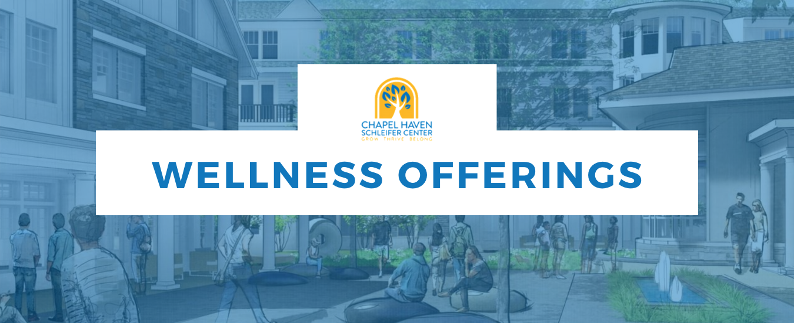
OUR MISSION
The goal of the Chapel Haven Wellness program is to provide the inspiration, education, and programs necessary to help our community live long, healthy, happy lives. We do this through the promotion of the 6 pillars of healthy happy living.
- PURPOSE
- PROPER NUTRITION
- REGULAR EXERCISE
- STRESS MANAGEMENT
- CONNECTION
- SELF CARE/ HYGIENE

The programs and offerings in this catalog are aimed at fueling the success of each individual in our community. We hope to see you in a variety of these classes and programs.

-Ryan McEachern, Wellness Director

WHAT’S NEW
- Hiking club is back! Come join us for some SPRING hiking at the best spots around New Haven.
- Megan from Aspen Yoga is still on maternity leave so Yoga will return in the Summer!
- Women’s Wellness is now offered as a Group Exercise class for the term!

WANT SOMETHING NEW?
We are always looking for ways to serve you better and provide the courses & classes you would like.
Please make your suggestions known here!

SMALL GROUP CLASS OFFERINGS
These classes have limited participation to allow enough individualized attention,
while still engaging with others in a social setting.

PRICING

IN-PERSON CLASSES
$275 per class section for the term unless otherwise noted in course description.

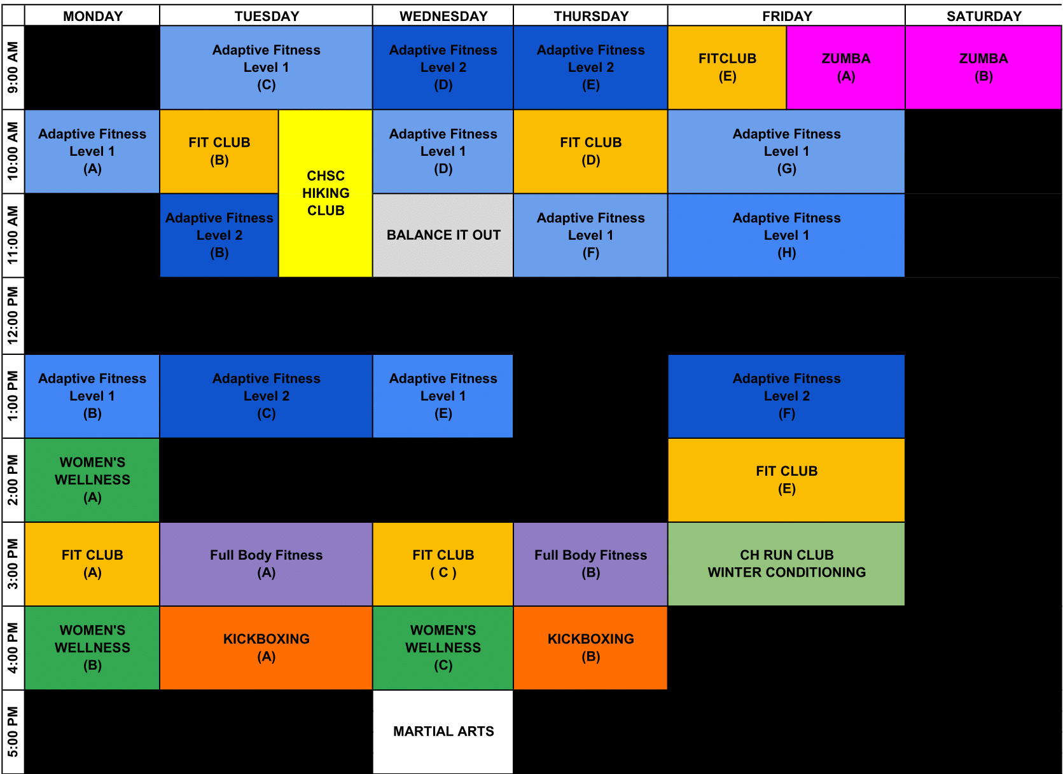

ADAPTIVE FITNESS LEVEL 1: with Ryan McEachern and/or Jacob Bellet
This is a 45-minute in-person small group training class geared for all fitness levels utilizing Chapel Haven’s state of the art group exercise room. In this class, the instructor will take you safely through a proper warm-up and exercise routine that will build functional strength, stamina, balance and improve cardiovascular fitness.

Session A - Mon 10 -11:00am
Session B - Mon 1 -2:00pm
Session C - Tue 9 -10:00am
Session D - Wed 10 -11:00am
Session E - Wed 1 - 2:00pm
Session F - Thu 11a - 12:00pm
Session G - Fri 10 - 11:00am
Session H - Fri 11 - 12:00pm

Location: SAIL Group Exercise Room

ADAPTIVE FITNESS LEVEL 2: with Alex and/or Jacob Bellet
********** PREREQUISITE: ADAPTIVE FITNESS 1 or WELLNESS STAFF APPROVAL**********
This is a 45-minute in-person small group training class geared for the more advanced fitness levels utilizing Chapel Haven’s state of the art group exercise room. In this class, the instructor will take you safely through a proper warm-up and exercise routine that will build functional strength, stamina, balance and improve cardiovascular fitness

Session B - Tue 11a –12:00pm
Session C - Tue 1:00 - 2:00pm
Session D - Wed 9-10:00am
Session E - Thu 9-10:00am
Session F- Fri 1- 2:00pm

Location: SAIL Group Exercise Room

BALANCE IT OUT (LIMITED MOBILITY) with Jacob & Alex
Get back to basics and focus on balance and functional movement at a slower pace. We will walk you through a
series of exercises that will increase your strength and mobility leaving you moving better and feeling more limber. This is a great class for anyone dealing with neck, knee, hip or back pain!
Session A – Wed. 11:00am-12:00pm with Jacob & Alex

Location: SAIL Group Exercise Room

CARDIO KICKBOXING with Isabel Skarzynski
Isabel is not just a personal trainer, but also a Black Belt in Tang Soo Do. She will help you kick your fitness into high gear with this high energy class that will build stamina, coordination and flexibility.
Session A – Tue. 4:00-5:00pm
Session B – Thu. 4:00-5:00pm

Location: SAIL Group Exercise Room

CHSC FIT CLUB with Ryan McEachern or Jacob Bellet
Join us for simple, safe and effective, weekly workouts targeting total body fitness. From warm up, to cool down you are guaranteed to get a great workout.
Session A - Mon 3 – 4:00pm
Session B - Tue 10 -11:00am

Session C - Wed 3 - 4:00pm
Session D- Thu 10 - 11:00am

Session E - Fri 9:00-10:00am
Session F – Fri 2:00- 3:00pm
Location: SAIL Group Exercise Room

CHSC RUN CLUB with Alex Lagase
Prepare for your first or next 5k, or explore your love of running with the CHSC RUN CLUB!
Session A –: Fri 3:00 – 4:00pm
Location: Courtyard

FULL BODY FITNESS with Isabel Skarzynski
Join us for simple, safe, and effective workouts targeting total body fitness. From warm-up, to cool down you are guaranteed to get a great workout.
Session A – Tue. 3:00-4:00pm
Session B – Thu. 3:00-4:00pm

Location: SAIL Group Exercise Room

HIKING AROUND CT with Ryan McEachern ** $300 per section

Get some fresh air while getting your fitness on! We will travel around the local CT area exploring awesome places to hike! This will be rain or shine, unless there is lightning! Some hikes will be a little longer, as some travel time is expected.
*** Make sure you have good hiking shoes, proper clothing, a water bottle, and your best attitude! ***

Session A – Tue. 10:00-12:00pm
Location: Meet in Courtyard

TRADITIONAL MARTIAL ARTS with Stratford Shotokan
Unleash your inner warrior and learn traditional karate.In this class, you will learn the basics of self-defense and bullyproof techniques while also developing discipline and focus.
Session A – Wed. 5:00-6:00pm
Location: SAIL Group Exercise Room

WOMEN’S WELLNESS with Izzy ** $300 per section ** Limited to 6 people
Purpose: to give women a space to exercise and have conversations around women's wellness and health including core and pelvic floor strength, menstruation, perimenopause and menopause, breast health, hormonal changes throughout the month in regards to exercise, healthy eating that fuels your body rather than drains it, the importance of strength training for bone health, and getting to/maintaining a healthy body weight
Classes are also grouped by age range to keep topics discussed during the discussion piece relevant.
Session A - Best for Ages 40+ – Mon. 2:00-3:00pm
Session B – Best for Ages 25-39 – Mon 4:00-5:00pm
Session C – Best for Ages 18-24 - Wed 4:00-5:00pm

Location: SAIL Group Exercise Room

ZUMBA with John Layseca
Join the fun of Zumba! Together, we will take the "work" out of workout, by mixing low & high-intensity moves for a fun, calorie-burning dance fitness party. Learn moves from salsa, merengue, cumbia, and many more influential dance styles.

Session A – Fri. 9:00-10:00am
Session B – Sat.9:00-10:00am
Location: SAIL Multipurpose Room
OTHER SERVICES

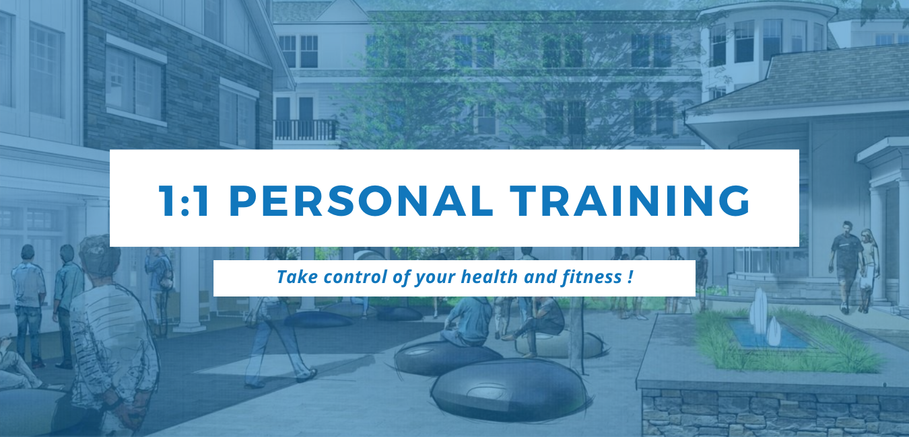

Personal Training is great when you need individualized support in approaching your health & fitness goals. Get the support you need to improve your health, lose unwanted weight, and adopt a healthier happier lifestyle.

Our clients come to us with different goals, needs, & capabilities so we strive to offer programs just as unique.

Our trainers have the best certifications in the industry such as NASM, Autism Fitness & Precision Nutrition and experience working with clients of all ability levels.

With sessions starting at $40 you are guaranteed to get the accountability, personalization, and attention necessary to achieve serious results in a fun, focused way.
GET STARTED NOW by booking a consultation with our Wellness Coordinator to find out about the different options and see if 1:1 training is right for you.

Get Started Today
CLICK HERE TO ENROLL

2 SESSIONS PER MONTH  $110 ($55 per session) |  | 1 SESSIONS PER WEEK  $215 ($53.75 per session)
2 SESSIONS PER WEEK  $360 ( $45 per session) | 3 SESSIONS PER WEEK  $510 ( $42.50 per session) |  | 4 SESSIONS PER WEEK  $640 ($40 per session)

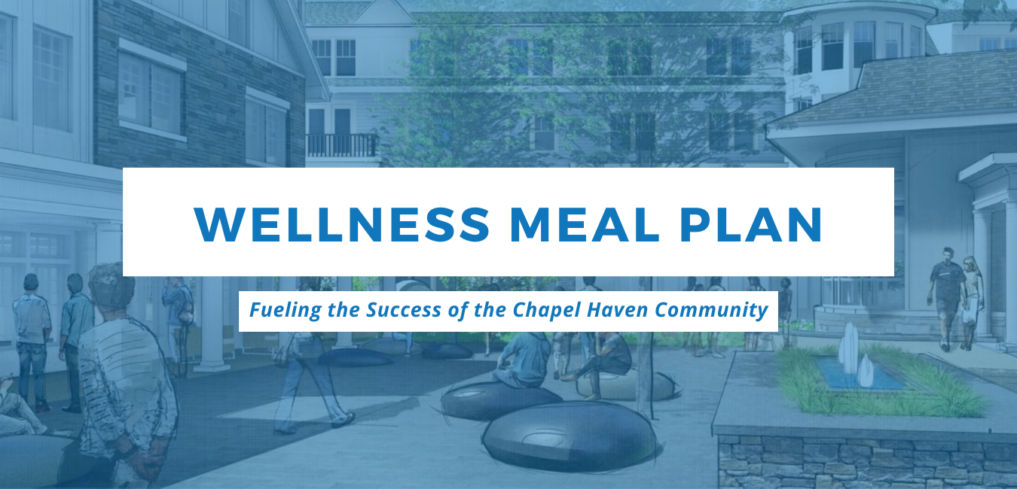
The new Wellness Meal Plan is fueling CHSC’s success with nutritious, delicious and ready-to-go meals!
The Wellness Meal Plan is a simple way to get nutritious, delicious, and ready-to-go meals delivered right to campus, ready to just heat and eat. Meals are prepared by professional chef’s so you can be sure they are cooked properly and taste great.
Each meal is made by EDIBOLIC KITCHEN with fresh whole foods and balanced properly so you can be sure your body gets the proper portions and nutrients it needs to function properly.
Everything is delivered right to campus each week so you can pick it up at your convenience and avoid the grocery stores and fast food restaurants. There are new items on the menu each week so you never get bored.
There is also a specialty menu for people with health conditions that require a low carb diet.
Ordering is “A LA CARTE” so you can get some, or all of your meals for the week based on your needs.
Book a call with our Wellness Coordinator to find out which option is best for you or CLICK HERE to get started.

QUESTIONS
Please reach out to Wellness@ChapelHaven.org with any questions about these programs.

